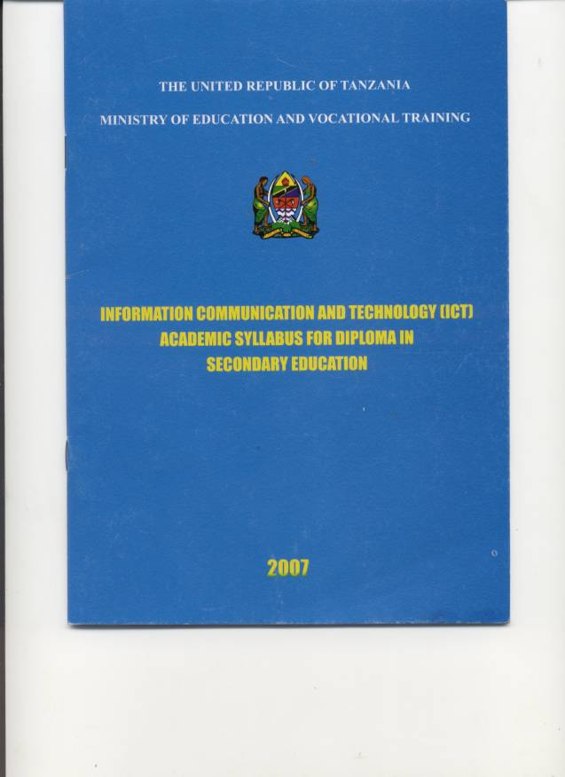
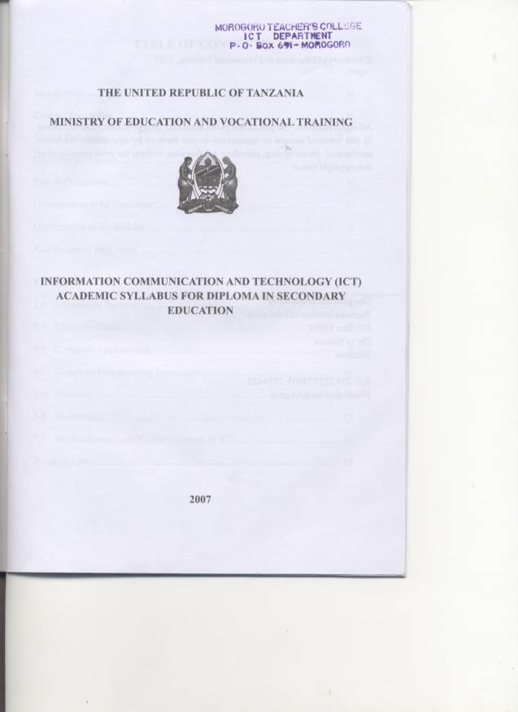

© Ministry of Education and Vocational Training, 2007
All rights reserved. No part of this publication may be reproduced, reported, stored in any retrieval system or transmitted in any form or by any means; electronic mechanical, photocopying, recording or otherwise, without the prior permission of the copyright owner.
Designed and prepared by
Tanzania Institute of Education
P.O. Box 35094
Dar es Salaam
Tanzania
Tel: 255 222 773005, 2774420
Email: director@tie.go.tz

Table of Contents
Introduction iii
Course Description: iii
Course Rationale iii
Goals for the Course iv
Course Objectives iv
Competences to be Developed iv
Organization of the Syllabus iv
Assessment of the Course v
1.0 Information Technology 1
2.0 Computer Basics 2
3.0 COMPUTER APPLICATIONS 4
4.0 COMPUTER PROGRAMMING LANGUAGES 8
5.0 WEBSITES 9
6.0 MULTIMEDIA 11
7.0 SOCIO-ECONOMIC AND CULTURAL ASPECT OF ICT 13
Reading List 15

Introduction
The education sector is acknowledging the growing concerns of forming a global community by using Information and Communication Technology (ICT). As an evidence of this acknowledgment, the primary and secondary schools syllabi in Tanzania have been prepared for pupils/students to learn Teknolojia ya Habari na Mawasiliano (TEHAMA) and Information and Computer Studies (ICS) as one of the subjects at those Education levels.

This syllabus therefore, is a need-base syllabus for Diploma in Secondary Education because teachers in schools need to be ICT literates in order to support students’ learning. This ICT academic syllabus for diploma in Secondary Education aims to produce academically competent teachers.

Course Description:
The course will be conducted in two years of study. It is a compulsory course with the intention of developing Information and Communication Technology (ICT) literate student teachers as well as upgrading their academic knowledge for use and for further studies. The mode of learning will involve theoretical and practical aspects in the participatory mode.

The course emphasis is on two main aspects; namely ICT as a subject for technological advancement and second, as a tool for integrating ICT skills in facilitating the process of teaching and learning of other subjects at the Ordinary level Secondary Schools.

The course contains seven topics, namely Information Technology, Computer Basics, Computer Applications, Computer Programming Languages, Websites, Multimedia and Socio-economic and Cultural aspect of ICT. The student teacher should spend 76 hours to complete the course.

Course Rationale
In traditional teaching methods the teacher used to be taken as the sole source of knowledge, while the learner used to be the recipient of the advancement of science and technology. There are various sources of knowledge, recognizing both the teacher and the learner, so the learner, in the learning process, becomes the center of activity.

We live in a global village where information and knowledge sharing is well facilitated by ICT. Our socio-economic, scientific technological and cultural interactions are a result of our education and training system. Thus, the teacher education curriculum needs to introduce ICT for catering to social and cultural demands of Tanzania citizen.

Basing on this shift, ICT is expected to facilitate the access to various sources of knowledge for enhancing learner centred approaches in teaching and learning. In addition to this, Tanzania education has to prepare learners to join the knowledge based on economy, where individuals become self advanced and liberated educationists for lifelong learning.

Goals for the Course
The course goals aim at enabling student teachers to:
a) develop ability to use the elements of transformation of information;
b) enhance the use of educational technologies and
c) promote awareness on the technological changes.

Course Objectives
The course objectives are to enable student teachers to:
a) develop knowledge and skills in the use of information and communication technology facilities;
b) develop awareness of current development and the impact of the use of ICT,
c) demonstrate skills of processing, interpreting and disseminating information;
d) develop and implement simple programs using structured languages;
e) design publish web-pages, and
f) help learners to realize the role of information and communication technology in socio economic and cultural development of the society.

Competences to be Developed
Expected competences are:
a) Demonstrating skills for the use of ICT facilities.
b) Processing, interpretating and disseminating information.
c) Creating simple computer programs.
d) Designing and developing websites.
e) Promoting the use of ICT in bringing about the development of the society
f) Keeping up to-date with the current development and issues related to every day use of ICT facilities.

Organization of the Syllabus
The syllabus contains preliminary pages and accompanied with course content. The content comprises topic names with specific objectives, teaching and learning strategies, teaching and learning resources, assessment procedure and reading lists which is annexed at the bottom of the syllabus.

Assessment of the Course
The assessment of the academic ICT syllabus for Diploma in Secondary Education is based on finding out the extent to which the student teacher are achieving the specific objectives of the ICT academic course.

The continuous assessment will be conducted by two methods; practical activities and tests. The proposed maximum score for each method per year is as shown on the following table:

S. No. | Types | Frequency | Weight (%)
1. | Test | 2 | 05
2. | Practical | 5 | 10
3. | Independent Study | 2 | 10
4. | Portfolio | 1 | 10
5. | Terminal Exam. | 2 | 10
6. | Participation | Full | 05
 |  | Total | 50

R. A. Mpama Chief Education Officer
Ministry of Education and Vocational Training
P.O. Box 9121
Dar es Salaam

Website: www.moe.go.tz

1.0 Information Technology

1.1 The Concept of Information

Estimated Time: 2 hours

Specific Objectives
The student teacher should be able to:
a) explain the concept of information;
b) relate data and information;
c) identify sources of information and
d) explain the significance of information

Teaching and Learning Strategies
(i) Brainstorming and concept mapping on the relationship between data and information.
(ii) Project work on identifying sources and significance of information.

Teaching and Learning Resources
(i) Student teacher’s experiences and literature
(ii) News paper, radio, television, textbook.

Assessment Procedures
(i) focused listing
(ii) concept maps and
(iii) tests

1.2 Information Dissemination

Estimated Time: 2 hours

Specific Objectives
The student teacher should be able to:
a) process the information;
b) describe the methods of dissemination of information; and
c) develop dissemination skills.; and
d) identify the limits of disseminating information.

Teaching and Learning Strategies
(i) Fieldwork and discussion on gathering, selecting, analyzing, interpreting and disseminating information
(ii) Story telling and discussion on the methods of disseminating information and its limitations.

Teaching and Learning Resources
Computer software, student teacher’s experience, internet, tape recorder, TV and video camera.

Assessment Procedures
(i) Field reports can be used on assessing the processing of information
(ii) Test can be used on assessing the methods of disseminating information and its limitation

2.0 Computer Basics

2.1 Computer Architecture

Estimated Time: 4 hours

Specific Objectives
The student teacher should be able to:
a) identify the parts of a computer;
b) describe the function of each part of the computer and how to connect computer peripherals to the computer system unit.

Teaching and Learning Strategies
(i) Group discussions on naming and describing the functions of each part of the computer.
(ii) Practical work on properly connecting the peripherals to the computer system unit.

Teaching and Learning Resources
Computer peripherals, drawings and operational manuals

Assessment Procedures
(i) Focused listing on assessing the parts of the computer and their functions.
(ii) Observation on connecting computer peripherals to the computer system unit.
(iii) Test.

2.2 Operating Systems

Estimated Time: 6 hours

Specific Objective
The student teacher should be able to:
a) categorize the types of operating systems;
b) identify features of operating system;
c) demonstrate basic operations of operating system

Teaching and Learning Strategies
(i) Group discussion on the types of operating systems and features of each.
(ii) Practical work on the basic operations of an operating system.

Teaching and Learning Resources
Computers, Drawings, CD-ROM with operating system software.

Assessment Procedures
i) The following techniques can be used for categorizing the types of operating systems and identification of their features:
-focused listing
-concept maps
-individual assignment
ii) observation and practical report can be used to assess basic operation of operating system.

2.3 Computer Networks

Estimated Time: 4 hours

Specific Objectives
The student teacher should be able to:
a) distinguish the types of networks;
b) describe computer networks layout;
c) identify computer networks components and
d) demonstrate the network configurations.

Teaching and Learning Strategies
(i) Library research and presentation on the types of networks, network layout and network devices.
(ii) Practical work on the network configuration.

Teaching and Learning Resources
Literature, computers, drawings and networking cable and accessories.

Assessment Procedures
i) Test or quiz on assessing the types of networks, computer networks layout and devices.
ii) Observation and practical report on assessing computer network configuration.

2.4 Computer Handling

Estimated Time: 2 hours

Specific Objectives
The student teacher should be able to:
a) manage the computer room;
b) create user count; and
c) use antivirus and other utility programs.

Teaching and Learning Strategies
(i) Discussion on the computer room management.
(ii) Practical work on creating a user account and using utility programs.

Teaching and Learning Resources
Computers, operation manuals, CD-ROM with utility program.

Assessment Procedures
i) Observation checklist on assessing the managing of the computer room.
ii) Individual assignments on assessing the creation of user account and using utility programs.

3.0 COMPUTER APPLICATIONS

3.1 Using Word Processing Program

Estimated Time: 6 hours

Specific Objectives
The student teacher should be able to:
a) explain the concept of word processing;
b) create a word processing document;
c) enhance word processing document outlook;
d) save a word processing document;
e) print a word processing document;
f) close and open a word processing document;

Teaching and Learning Strategies
(i) Think-pair-share on the meaning, types and functions of word processing program.
(ii) Practical work on:
-opening and closing a word processing program
-typing a paragraph
-saving, closing, and opening a file
-formatting and editing a document
-insetting an object
-printing and using help facility.

Teaching and Learning Resources
Computers and written text

Assessment Procedures
i) Typed essay on assessing the meaning, types and functions of word processing program.
ii) Observation, practical report, individual assignment, portfolio can be used to assess the following.
-opening a word processing program
-typing a paragraph
-saving a document
-opening a file
-formatting a document
-editing a document
-inserting an object
-using help facility
-closing a document
-closing the word processing program

3.2 Using Spreadsheets Program

Estimated Time: 6 hours

Specific Objectives
The student teacher should be able to:
a) explain the concept of spreadsheet;
b) create a worksheet
c) enhance worksheet data
d) create charts
e) save a worksheet
f) print a worksheet data
g) close and opening a worksheet

Teaching and Learning Strategies
(i) Discussion on the meaning, types and functions of spreadsheet program.
(ii) Practical work on:
-opening and closing a spreadsheet program.
-entering data
-perform calculations
-saving, closing and opening a spreadsheet file
-formatting worksheet data
-creating a chart
-inserting a row, a column and worksheet
-printing and using help facility.

Teaching and Learning Resources
Computers, data and calculator

Assessment Procedures
(i) Defining features matrix, concept maps or quiz can be used to assess the meaning, types and functions of spreadsheet program.
(ii) Observation, practical report, individual assignment, self assessment can be used to assess the following:
-opening and closing a spreadsheet program.
-entering data
-perform calculations
-saving, closing and opening a spreadsheet file
-formatting worksheet data
-creating a chart
-inserting a row, a column and worksheet
-printing and using help facility.

3.3 Using Presentation Program

Estimated Time: 6 hours

Specific Objectives
The student teacher should be able to:
a) explain the concept of presentation;
b) create a presentation;
c) show presentation;
d) print a presentation;

Teaching and Learning Strategies
(i) Brainstorming and discussion on the meaning, types and functions of the presentation program.
(ii) Project work on:
-extracting information to be presented;
-opening and closing a presentation program;
-entering data;
-saving, closing and opening a presentation file;
-editing and formatting slides;
-connecting the computer to the projector;
-rehearsing and showing the presentation;
-printing and using help facility.

Teaching and Learning Resources
Computers, data, projector, remote control, white sheet, speaker, slide notes, handouts, transparent sheets.

Assessment Procedure
i) Test or quiz can be used to assess the meaning, types and functions of presentation program.
(ii) Observation, practical report, individual assignment, self assessment can be used to assess the following:
-extracting information to be presented;
-opening and closing a presentation program;
-entering data;
-saving, closing and opening a presentation file;
-editing and formatting slides;
-connecting the computer to the projector;
-rehearsing and showing the presentation;
-printing and using help facility.

3.4 Using Database Program

Estimated Time: 4 hours

Specific Objectives
The student teacher should be able to:
(i) explain the concept of database;
(ii) design and plan a database structure;
(iii) create a database
(iv) print a report

Teaching and Learning Strategies
i) Reading text and discussion on the meaning, types and functions of database program.
(ii) Practical work on:
-opening, saving and closing a database program;
-choosing, designing and planning the database structure;
-creating data storage, data entry, data filter and report;
-entering data, editing data and using help facility.

Teaching and Learning Resources
(i) Computers, Samples of database structure and data.
(ii) Sample of Database program.

Assessment Procedures
i) Test or Quiz can be used to assess the meaning, types and functions of presentation program.
ii) Observation, practical report, individual assignment, portfolio on assessing the following:
-opening, saving and closing a database program;
-choosing, designing and planning the database structure;
-creating data storage, data entry, data filter and report; and
-entering data, editing data and using help facility.

3.5 Using Internet

Estimated Time: 2 hours

Specific Objectives
The student teacher should be able to:
a) explain the concept of Internet;
b) open the Website;
c) Search information;
d) Print a searched information;
e) Communicate through e-mail.

Teaching and Learning Strategies
i) Discussion on the function and significance of the internet program.
iii) Practical work on:
-opening and closing Internet account, sending, receiving, replying emails and attaching files;
-Searching, downloading and printing the searched information; and
-discussion and value clarification on the downloaded information

Teaching and Learning Resources
Computers, Internet, literature and student teachers’ experiences

Assessment Procedures
i) Test or Quiz on assessing the functions and significance of the Internet program.
ii) Observation, practical report, individual assignment, self-assessment on assess the following:
-opening and closing Internet account, sending, receiving, replying emails and attaching files.
-searching, downloading and printing the searched information and value clarification on the downloaded information

4.0 COMPUTER PROGRAMMING LANGUAGES

4.1 Concept of programming

Estimated Time: 2 hours

Specific Objectives
The student teacher should be able to:
a) explain the concept of programming;
b) outline the types of programming languages; and
c) select appropriate programming language.

Teaching and Learning Strategies
Brainstorming and discussion on the meaning of programming, types and choice of programming languages.

Teaching and Learning Resources
Student teacher’s experiences, computers

Assessment Procedure
Test or quiz on to assessing the meaning of programming, types and choice of programming languages.

4.2 Developing a program

Estimated Time: 8 hours

Specific Objectives
The student teacher should be able to:
a) identify a problem;
b) design a program;
c) code program scripts;
d) baselining a program;
e) test and debug a program;
f) document a program; and
g) implement the program.

Teaching and Learning Strategies
Project work and presentation on developing a program using the following steps:
(i) Identify a problem
(ii) Design a program
(iii) Code program scripts
(iv) Test and debug a program
(v) Implementing the program

Teaching and Learning Resources
Computer, programming language, literature, sample of the programs and Internet.

Assessment Procedure
The following assessment techniques can be used to assess how to develop a program:
-Portfolio on developed programs
-Project report on a developed program
-Individual assignment

5.0 WEBSITES

5.1 Website Development

Estimated Time: 6 hours

Specific Objectives
The student teacher should be able to:
a) explain a concept of Web site development
b) design and plan a website structure; and
c) create a website.

Teaching and Learning Strategies
(i) Think-pair-share on the meaning, significances and functions of the website development.
(ii) Practical work on:
-designing and planning a website structure
-creating a website.

Teaching and Learning Resources
(i) Student teacher’s experiences
(ii) Literature
(iii) Computer
(iv) Sample of websites

Assessment Procedures
(i) Quiz or test can be used to assess the meaning of the website development, significance and functions of the website.
(ii) The following techniques can be used to assess the designing and planning a website structure as well as creating a website:
-Portfolio
-Individual assignment
-Practical report

5.2 Publishing Web Pages

Estimated Time: 2 hours

Specific Objectives
The student teacher should be able to:
a) outline steps of publishing web pages;
b) publish a website; and
c) update the website

Teaching and Learning Strategies
(i) discussion on steps of publishing web pages.
ii) Practical work on publishing
iii) Uploading the website.

Teaching and Learning Resources
Computers, Internet, sample of websites, prepared website, domain name and Internet browser

Assessment Procedure
Observation, portfolio and test can be used to assess publishing and updating website.

6.0 MULTIMEDIA

6.1 The concept of multimedia

Estimated Time: 2 hours

Specific Objectives
The student teacher should be able to:
a) explain the meaning and significance of multimedia;
b) outline the elements of multimedia; and
c) identify types of multimedia;

Teaching and Learning Strategies
Think-pair-share on the meaning, elements, types; and choice of multimedia

Teaching and Learning Resources
Computers, literature and internet

Assessment Procedures
Test or quiz on assessing the meaning, elements, types and choice of multimedia.

6.2 Educational multimedia

Estimated Time: 8 hours

Specific Objectives
The student teacher should be able to:
a) make educational multimedia; and
b) use educational multimedia program.

Teaching and Learning Strategies
(i) Practical work on making and using educational multimedia
(ii) Brainstorming on the concept of multimedia.

Teaching and Learning Resources
Computers, camera, scanner, microphone, speaker, video editor, mixer, CD-ROM and tapes

Assessment Procedures
The following techniques can be used to assess the practical work on making and using educational multimedia:
-practical report
-observation
-individual assessment
-audio and videotaped protocols
-portfolio

6.3 Interactive contents

Estimated Time: 3 hours

Specific Objectives
The student teacher should be able to:
a) explain the concept of interactive content.
b) create an interactive content and
c) use the interactive content.

Teaching and Learning Strategies
(i) Practical work on creating and effective use of interactive content program.
(ii) Brainstorming on the concept of interactive content.

Teaching and Learning Resources
(i) Computers, computer programs, user manual, Stylus and CD-ROMS
(ii) Sample of interactive content.

Assessment Procedures
The following techniques can be used to assess the practical work on making and using interactive contents:
-practical report
-observation
-individual assignment
-audio and videotaped protocols
-portfolio

6.4 Integration of ICT in teaching and learning process

Estimated Time: 3 hours

Specific Objectives
The student teacher should be able to:
a) use computer based training software; and
b) apply educational programs in teaching other subjects

Teaching and Learning Strategies
(i) Practical work and team teaching (subject experts) on creating and using of computer based training software.
(ii) Field work on applying educational programs in teaching other subjects

Teaching and Learning Resources
(i) Computers, sample lessons from different subjects, CD-ROMs
(ii) Educational curriculum (primary, secondary, teachers education)

Assessment Procedures
The following techniques will assess the creation and use of computer based training software as well as applying educational programs in teaching other subject:
-Student generated test question
-Teacher designed feedback forms
-Observation
-Portfolio

7.0 SOCIO-ECONOMIC AND CULTURAL ASPECT OF ICT

7.1 Impact of ICT in the Society

Estimated Time: 1 hour

Specific Objectives
The student teacher should be able to:
a) explain the positive impact of ICT in the society; and
b) explain the negative impact of ICT in the society.

Teaching and Learning Strategy
Debating, values clarification and future wheel on positive and negative impact of ICT in the society.

Teaching and Learning Resources
(i) Student teachers’ experiences , literature and internet.
(ii) Radio, television programs, video cassette.

Assessment Procedure
The following techniques can be used to assess the positive and negative impact of ICT in the society:
-Misconception/preconception checklist
-Test
-Report on every daily ethical dilemma

7.2 E-learning

Estimated Time: 1 hour

Specific Objectives
The student teacher should be able to:
a) explain the concept of e-learning; and
b) use e-learning.

Teaching and Learning Strategies
(i) Discussion on the concept of e-learning
(ii) Case studies or story telling on the use of e-learning

Teaching and Learning Resources
(i) Student teacher experiences, Computer, Internet and CD-ROMS
(ii) Sample of e-learning platform and e-books

Assessment Procedures
The following techniques can be used to assess the meaning and significance and use of e-learning:
-test
-quiz
-observation
-electronic mail feedback
-portfolio

Reading List
